Please use below steps to start server

1. Start WAR file using java -jar warFileName.war

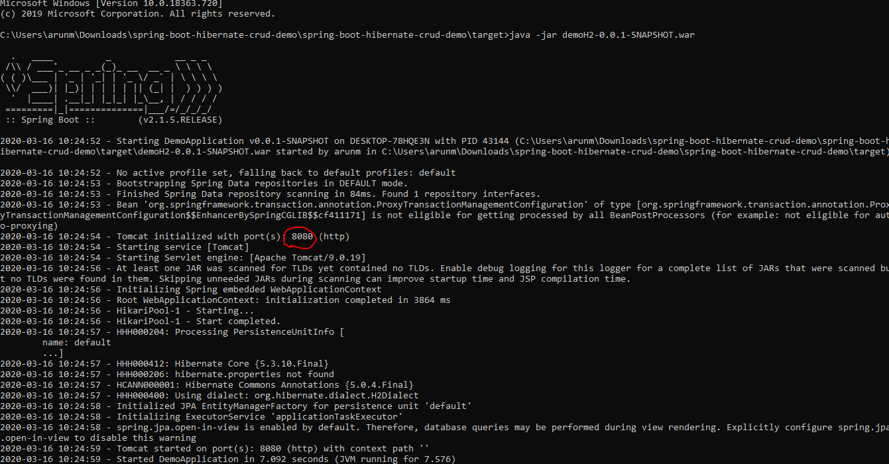

Its listen on port 8080.

1. Once its started hit <http://localhost:8080/>

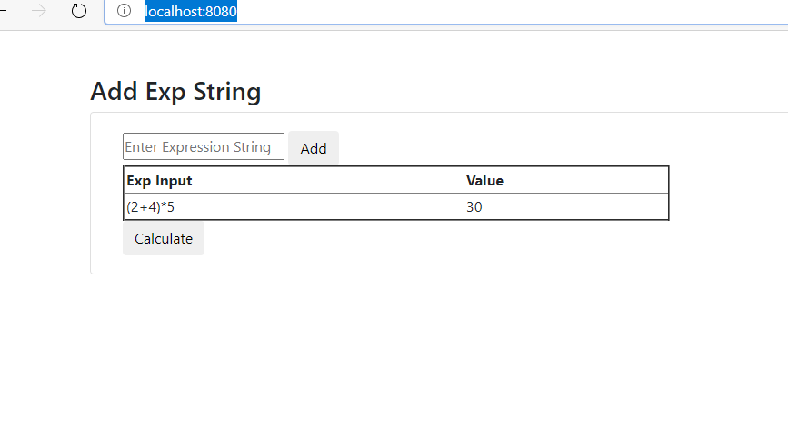

Enter Expression string and add

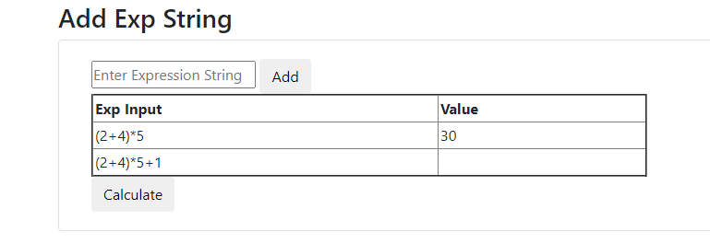

Once added click on ‘’Calculate” it will generate result.

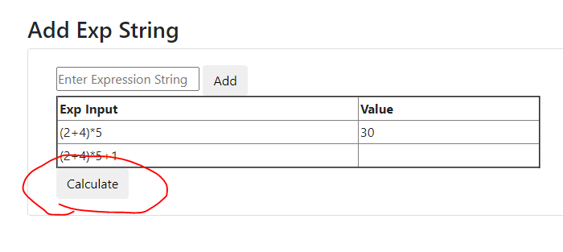

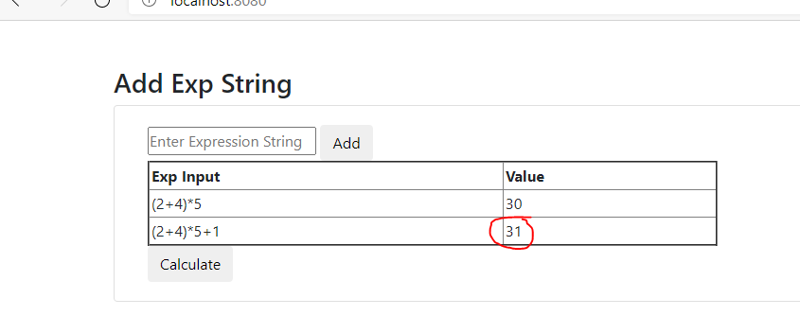

H2 database details-

1. You can access h2databse <http://localhost:8080/h2>

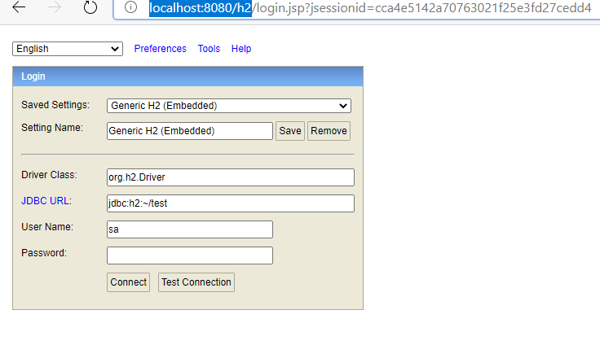

Username=”sa”/Password=””

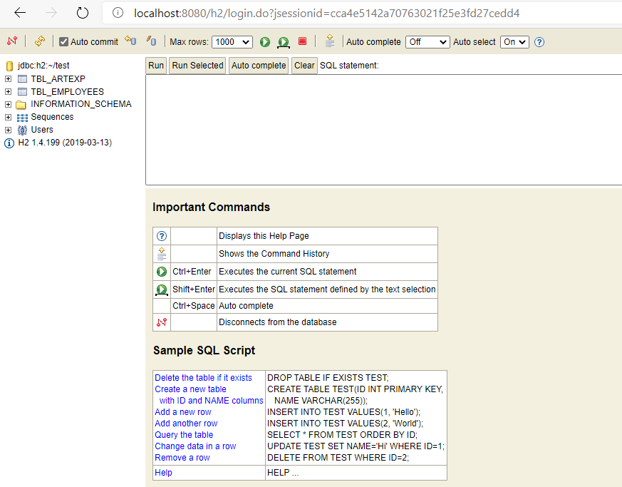

Here you can see I have created one table named ‘TBL_ARTEXP’

